20170300485

**MINISTRY OF INTERIOR**

**Based on Article 396 indent 1 from the Law on Road Traffic Safety („Official gazette of the Republic of Macedonia no 169/15, 226/15 and 55/16) the Minister of Interior, with the Minister of Education and Science have adopted the following**

**RULEBOOK ON THE CRITERIA, MANNER OF OPERATION OF THE DRIVING SCHOOLS THE TRAINING AND EDUCATION PROGRAM, THE STAFF, THE EQUIPMENT NEEDED AS WELL AS THE RECORDS THAT NEED TO BE KEPT BY THE DRIVING SCHOOLS FOR EDUCATION OF DRIVER CANDIDATES**

**I. GENERAL PROVISIONS**

Article 1

This Rulebook shall prescribe the criteria for the manner of operation of the driving schools, the training and education plan and program, the staff, the equipment needed and the records that need to be kept by the driving schools for education of driver candidates.

**II. CRITERIA, MANNER OF OPERATION OF THE DRIVING SCHOOLS, STAFF AND EQUIPMENT NEEDED**

Article 2

The driving school for education of the driver candidates shall provide the following

1. Premises 20 m 2 and business space equipped properly with video surveillance to perform the theory classes;

2.Space equipped for reception of candidates and for operation of the professional manager of the driving school and business space of at least 9 m 2;

3. Teaching materials, assistive tools and computer equipment to implement the curriculum and record keeping;

4. Traffic autodrome (polygon);

Motor drive vehicles and

Professional staff.

(2) Information technology and equipment as well as software web application shall be used by the driving school to keep records and enable and establish a sole data base for performance of the training of the driver candidates

(3) In order to keep the records from paragraph (2) of this Article the driving school shall apply proper techniques and organization measures, in line with the prescriptions for personal data protection.

**1. Premises (classroom) equipped for the theory part**

Article 3

(1) The premises for the theory classes (in the further text: classroom) shall be equipped in a manner providing conditions to perform the theory classes and the trial exam.

(2) The classroom mentioned in paragraph (1) of this Article shall cover space of at least 1,5 m2 per candidate, i.e. at least five m2 for the educator of traffic rules and regulations (theory part).

(3) The classroom shall be equipped with video surveillance one work desk, one school board and teaching materials, technical and computer equipment according to the normative for equipment of a school cabinet for traffic education with the possibility to display drawings and projection of films and animations and with proper heating, ventilation, lights and sanitary premises.

(4) in order to provide the video surveillance from paragraph (3) of this Article, the classroom shall be equipped with cameras which in accordance with the dimensions and features of the space enable quality video recording that may serve to recognize the candidate and the educator, the total training process according to the education plan and program for the theory part with the possibility to archive and document the recorded material from the executed education of the candidates.

(5) The recorded material from paragraph (4) of this Article shall be stored in the premises of the driving school in line with the regulations from the area of personal data safety.

**2. Premises for driver candidates receipt and manager operation**

Article 4

The space for reception of candidates and operation of the professional manager of the driving school shall be equipped in a manner that provides conditions for driving school operation management.

The space from paragraph 1 of this article shall be business space and shall meet the standards according to the prescriptions for the general measures for safety and health in the work for operative and auxiliary premises and spaces.

Teaching materials, assistive tools and computer equipment for implementation of the curriculum

To implement the curriculum, the driving school shall provide:

Schematics of traffic signs, road marks and signs given by a uniformed police officer in the traffic;

Schematics, drawings, photographs and other assistive tools to explain the rules of the traffic (overtaking, passing advantage, change of the driving direction, lane switching, stopping, parking, stopping due to various speeds etc.) traffic situations and elements on the road which may be in electronic form;

Models or schematics of the devices of the motor vehicles significant for the safety of the road traffic (navigation devices, stopping devices, light sign devices and devices for road lighting as well as the vehicle and vehicle labeling, tire section etc.) which may be in electronic form;

**3. Completed equipment of vehicles from a proper category;**

Section, model of a diesel motor or a drawing (with section) of a diesel motor for motor vehicles from C and D category and C1 and D1 sub- category.

Schematics, drawings, photographs, films, proper computer equipment (computers, projector, video presentation devices, television, graphoscope and other technical devices) for execution of the classes and

7. Necessary professional literature from the area of the prescriptions for the safety in the traffic on the roads (laws, rulebooks, student books, manuals, test exercises and magazines) to skill the driver candidates and professionally perfect the instructor- drivers.

**4. Traffic autodrome (polygon**)

Article 6

(1) For the initial skilling of the driver candidates of a motor vehicle or a tractor, the driving schools shall provide a traffic autodrome (polygon) composed of one or more surfaces representing one entirety, marked traffic surfaces to perform actions with a vehicle envisaged in the initial skilling of the driver candidates for practical navigation of a motor vehicle or tractor as well as for candidate examination, and not public roads.

(2) The traffic autodrome (polygon) has a proper traffic joint with the street, and there is a visible board with dimensions 160x100 cm, displaying the number of the use license issued by the competent ministry, the name of the legal or physical entity managing it, as well as the name of the entities using it under lease.

(3) The traffic and technical elements of the traffic autodrome (polygon) shall meet the standards according to the technical prescriptions for construction of roads and are marked with a vertical and horizontal traffic signalization (traffic signs and road marks), according to the prescriptions from traffic signs, equipment and signalization on the road.

(4) The traffic and technical elements of the traffic surfaces from paragraph 3 of this article have been determined according to a Drawing (Appendix number 1, 1.1, 1.2 and 1.3).

**5. Candidate skilling vehicles**

Article 7

The skilling of the candidates to become drivers is performed with motor drive vehicles such as:

1. „А1“ category with a motor vehicle from „А1“ category, motorcycle with no trailer, with volume of at least 120 cm3, that can achieve speed of least 90 km/h;

2. „А2“ category with a motor vehicle from „А2“ category motorcycle with no trailer, with volume of at least 400 cm³ and engine power of at least 25 kW;

3. „А“ category with a motor vehicle from „А“ category motorcycle with no trailer, with volume of at least 600 cm³ and engine power of at least 40 kW;

4. „B“ category with a motor vehicle from „B“ category, that may have automated gear stick, four wheel vehicle that can achieve speed of at least 100 km/h;

5. „BЕ“ category with vehicle group from „BЕ“ category, combination composed of a B category vehicle and a tailor with maximum allowed mass of at least 1000 kg that may achieve speed of at least 100 km/h, that does not fall under B category. The loading part shall consist of a closed box (permanent or temporary execution with cover) that is high and wide as the motor vehicle and the closed box may be a little wider than the motor vehicle if the rear view viewing option is available only by the use of external rear view mirrors of the motor vehicle, and the trailer has the total mass of 800 kg (loaded vehicle mass);

6. „C1“ category with a motor vehicle from „C1“ category, vehicle with maximum allowed mass of at least 4000 kg, 5 m wide, that can achieve speed of least 80 km/h, equipped with anti- block brakes . The loading part shall consist of a closed box (permanent or temporary execution with cover) that is high and wide as the cockpit;

7. „C1Е“ category with vehicle group from „C1Е“ category combination composed of a C1 category vehicle and a trailer with maximum allowed mass of at least 1.250 kg, this combination is at least 8 m wide and can achieve speed of least 80 km/h. The loading part shall consist of a closed box (permanent or temporary execution with cover) that is high and wide as the cockpit the and trailer has the total mass of 800 kg (loaded vehicle mass);

8. „C“ category with a motor vehicle from „C“ category with maximum allowed mass of at least 12 000 kg, 8 m long and 2,4 m, wide, that can achieve speed of least 80 km/h, equipped with anti- block brakes . The loading part shall consist of a closed box (permanent or temporary execution with cover) that is high and wide as the cockpit, the vehicle has the total mass of 10 000 kg (loaded vehicle mass);

9. „CЕ“ category with vehicle group from „CЕ“ category combination composed of a C category vehicle and a trailer at least 7,5 m wide, and maximum allowed mass of 20 000 kg, at least 14 m long and at least 2,4 m wide and can achieve speed of least 80 km/h. The loading part shall consist of a closed box (permanent or temporary execution with cover) that is high and wide as the cockpit, the combination has the total mass of 15 000 kg (loaded vehicle mass);

10. „D1“ category with vehicle group from „D1“ category with maximum allowed mass of at least 4000 kg, at least 5 m long, can achieve speed of least 80 km/h, equipped with anti- block brakes;

11. „D1Е“category with vehicle group from „D1Е“ category combination composed of a D“ category and a trailer with maximum allowed mass 1250 kg can achieve speed of least 80 km/h. The loading part shall consist of a closed box (permanent or temporary execution with cover) that is high and wide at least two meters the trailer has the total mass of 800 kg (loaded vehicle mass);

12. „D“ category with vehicle from „D“ category, at least 10 m long and at least 2,4 m wide, can achieve speed of least 80 km/h, equipped with anti- block brakes;

13. „DЕ“ category with vehicle group from „DЕ“ category combination composed of „ D“ category “ vehicle and a trailer with maximum allowed mass of at least 1250 kg, at least 2,4 m wide, can achieve speed of least 80 km/h. The loading part shall consist of a closed box (permanent or temporary execution with cover) that is high and wide at least two meters the trailer has the total mass of 800 kg (loaded vehicle mass);

14. „F“ category with vehicle from , tractor (with cockpit) not with caterpillars and auxiliary vehicle that can carry at least 1.500 kg.

Article 8

(1) The vehicles of the driving schools for skilling of driver candidates and taking the driving exam, aside to the mandatory equipment, in accordance with the law, should be equipped with:

Vanity mirror for the B category vehicles;

Fire extinguisher;

Special label reading Driver School which at night and in conditions of decreased visibility is lit. The marking shall be with the following dimensions 75x15 and shall have own light source. It shall be set on the highest point of the vehicles of all categories except the A, A1 and A2 category vehicles.

4 Safety reflective vest in yellow with engraved Latin letter L in white and dimensions 15x9x3 cm on a blue base with dimensions 25x25 cm for the vehicles from A, A1 and A2 category

a two sided recording camera with own source, set on the internal part of the vehicle on the front windshield for A1, A2 and A categories and F national category set in the vehicle navigated by the driver- instructor who conducts the training in a manner that would serve to recognize the driver candidate and the driver instructor;

6. A device for audio communication for the vehicles of A, A1 and A2.

7. Special plate with the letter L on the vehicle serving to practically perform the driver candidate.

(2) The recorded material from paragraph (1), item 5 of this Article shall be stored in the premises of the driving school, in line with the regulations for personal data protection.

Article 9

(1) The vehicles for skilling of driver candidates from the „B“ „ C1“ and „C“ shall be equipped with double foot commands, technically correct and registered in the Republic of Macedonia.

(2) The vehicles for skilling of driver candidates from the rest of the categories should be technically correct and registered.

(3) The vehicles for skilling of driver candidates from the А1, А2, А, BЕ, C1, C1Е, C, CЕ, D1, D1Е, D, DЕ and F categories that are being leased, may be leased only by one driving school, and one vehicle must not be used for training in two driving schools.

**6. Professional staff**

Article 10

The professional staff in the driving school shall be composed of: an expert manager, at least 1 teacher for the programme for traffic rules and regulations (theory) and at least 2 instructor drivers for B category for implementation of the curriculum for vehicle navigation (practice).

**III. TEACHING PLAN AND PROGRAM FOR TRAINING**

Article 11

(1) Skilling curriculum for the driver candidates of motor vehicles, motorcycle drivers and tractor drives shall be consisted of traffic rules and regulations- theory and vehicle navigation -practical part, for which the driving school shall issue a certificate.

(2) The education plan and program for training of candidates for navigation with mobile machine, bicycle with auxiliary engine, moped and easy quadricycles shall be consisted only from a theory part.

**1. Theory part**

Article 12

(1) The theory part of the program for skilling driver candidates for motor vehicles is consisted of learning of the traffic signs, rules and regulations.

(2) The theory part of the program, for skilling driver candidates for tractor navigation, work machines, moto cultivators and bicycle with auxiliary motor and moped shall cover only the safety regulations in the traffic on the roads, referring to the traffic rules, traffic signs and their meaning and the signs given by the uniformed police officers in the performance of control and traffic regulation as well as the dangers occurring due to irregular undertake of actions in the traffic and the bases of functioning of the devices of the vehicles on motor drive significant for the safety in the traffic on the roads.

Article 13

(1) To perform the theory part from the program for skilling driver candidates for motor drive vehicles (motor vehicles, motorcycles, tractors and work machines) for the following categories, subcategories and national categories of vehicles the following is envisaged:

- For „АМ“ category - 12 classes;

- For „А1“category - 16 classes;

- For „А2’ category - 16 classes; - For „А“ category - 16 classes;

- For „B“ category - 20 classes;

- For „BЕ“ category - four classes;

- For „C1“category - ten classes;

- For „C1Е“category - four classes;

- For „C“ category - ten classes;

- For „CЕ“ category - four classes;

- For „D1“category - ten classes;

- For „D1Е“category - four classes;

- For „D“ category - ten classes;

- For „DЕ“ category - four classes;

- For „F“ national category -12 classes;

- For „G“ national category -12 classes.

(2) for the driver that has been issued driver license for „А1“, „А2“ and „А“ category shall take four classes for skilling for „B“ category.

(3) for the driver that has been issued driver license for „АМ“ national categories „F“ and „G“ shall take eight classes for skilling for „B“ category.

(4) for the driver that has been issued driver license for „B“ category, shall take four classes for skilling for „А1“, „ А2“ and „А“ category.

(5) for the driver that has been issued driver license for „C1“, „D1“, „C1Е“, „D1Е“category shall take four classes for skilling for „C“, „D“,„CЕ“ and „DЕ category.

Article 14

The classes from the theory part of the curriculum last for 45 minutes and in one day the candidate may realize at most 4 classes.

Article 15

(1) The trial exam shall contain questions being valorized with points depending on the content of the question.

(2) The driver candidate shall have the needed knowledge if they score at least 85% in the trial exam.

(3) The content of the exam from paragraph 1 of this article may not be identical with the content of the exam for the driver license.

**2. Practical part**

Article 16

The practical part of the program for skilling of the driver candidates for motor vehicles, motorcycles and tractors shall refer to the performance of actions with a motor vehicle, motorcycle or a tractor meaningful to the successful and safe navigation in accordance with the traffic rules and road conditions as well as the mastering of the technique and skill for vehicle navigation.

Article 17

The class from practical skilling is 45 minutes and during one day the candidate may take at most 2 classes.

.

Article 18

(1) The performance of the practical part of the program for skilling of driver candidates for motor vehicles, motorcycles and tractor drivers shall be carried out with initial skilling at a traffic autodrome (polygon) and then the skilling continues on a public road outside the community and a public road inside the community during the day and in night conditions.

(2) The total number of classes for practical enabling of driver candidates is:

- For „А1“category - 16 classes;

- For „А2“category - 16 classes;

- For „А“ category - 16 classes;

- For „B“ category - 36 classes;

- For „BЕ“ category - eight classes;

- For „C1“category - 20 classes

- For „C1Е“category - eight classes;

- For „C“ category - 20 classes

- For „CЕ“ category - eight classes;

- For „D1“category - 16 classes;

- For „D1Е“ category - eight classes;

- For „D“ category - 16 classes;

- For „DЕ“ category – eight classes and

- For „F“ national category - 12 classes.

(3) In the cases from paragraph 2 of this article, the number of the teaching classes for the driver having driver license for the following categories is:

- „C1“ being skilled for „C“ category –four classes;

-„C1Е“being skilled for „CЕ“ category –four classes;

- „D1Е“being skilled for „DЕ“ category –four classes;

- „D1“being skilled for „D“ category –four classes;

- „F“ national category being skilled for „B“ twenty-four classes.

Article 19

(1) The initial skilling of the traffic autodrome (polygon) shall be:

- „А1“ category - four classes; - „А2“ category - four classes;

- „А“ category - four classes;

- „B“ category - four classes;

- „C1 “category - four classes;

- „C“ category - four classes; - „D1“ category - four classes;

- „D“ category - four classes;

- „F“ national category - two classes.

(2) The initial skilling of the traffic autodrome (polygon) for B category if the candidate has „F“ national category shall be four classes.

Article 20

(1) The number of classes from the practical part of the program for skilling on a public road outside the community and inside, during the day, for the following categories and national categories shall be:

- „А1“ category - ten classes;

- „А2“ category - ten classes;

- „А“ category - ten classes;

- „B“ category - 28 classes;

- „BЕ“ category - six classes; - „C1“ category - 14 classes;

- „C1Е“ category - six classes; - „C“ category - 14 classes

- „CЕ“ category - six classes; - „D1“ category - ten classes; - „D1Е“ category - six classes;

- „D“ category - ten classes;

- „DЕ“ category - six classes and

- „F“ national category - eight classes.

(2) In the cases from paragraph 1 of this article, the number of the teaching classes for the driver having driver license for the following categories and the national F category is:

- „C1“being skilled for „C“ category - four classes;

- „C1Е“being skilled for „CЕ“ category - four classes;

- „D1“being skilled for „D“ category - four classes;

- „D1Е“being skilled for „DЕ“ category - four classes and

- „F“ national category being skilled for „B“ category - 20 classes.

Article 21

The number of classes from the practical part of the program for skilling on a public road outside the community and inside, during the day, for all categories shall be two classes.

Article 22

The curriculum for skilling of driver candidates for motorcycles, for skilling of driver candidates for motor vehicles of all categories and for skilling candidates for tractor drivers and work machine drivers, moto cultivator and bicycle with an auxiliary motor and moped have been given in appendix 2 and appendix 2.1 which is an integral part of this rulebook.

**IV. RECORDS THAT NEED TO BE KEPT BY THE DRIVING SCHOOLS FOR SKILLING OF DRIVER CANDIDATES**

Article 23

The driving school shall keep the following records on the organization and implementation of the candidate skilling manually and electronically:

1. Book for records of candidates and skilling drivers containing the ordinal number, personal name, name of one of the parents, date and place of birth, residence, address, category the candidate is being skilled for and place and date of issuance of the certificate for the health and psycho-physiological capability for motor vehicle navigation, the part of the programme for which the skilling is performed (theory and practice), number of held classes, time during which the candidate has been skilled, date of the examination of the road rules and traffic signs knowledge (trial exam), date of the issued certificate for skilling, data on the success of the candidate on the driver exam, name, surname of the instructor skilling and note (Appendix number 3 ( 1/2 and 2/2);

2. Records on additional skilling of candidates for drivers from the practical part covering ordinal number, personal name, name of one of the parents, date and place of birth, residence, address, category the candidate is being skilled for, the part of the programme for which the skilling is performed, number of held classes, time during which the candidate has been skilled, name, surname of the instructor skilling and note (Appendix number 3.1);

3. Records keeping on the performed examination of the candidate from the area of the traffic rules and signs containing ordinal number, personal name, name of one of the parents, date and place of birth, residence, address, category the candidate is being skilled for (A1, A2, A, B and F national category) and place and date of examination, trial test number, which time is the test taken, the success shown, name, surname of the instructor skilling and note (Appendix number 3.5);

Article 24

(1) For the skilling of the candidate drivers, the driving school keeps the following records manually:

1. Journal of candidates and skilling drivers containing the number under which they can be found in the book of records, date and time of the held classes, category for which they are being skilled, subject and lesson, name surname and signature of the educator and name and surname of the candidates that attended the education signed personally by them and a note (Appendix number 3.2);

2. Chart for recording keeping of the driver candidates from the practical part of the program for skilling the candidates for drivers containing the name of the driving school., name and surname of the candidate, date and place of birth, address/ residence phone number, number of health certificate and the instructor, the number under which they have been recorded in the book, category, the type and the registration number of the vehicle and ownership and data on the duration of the skilling of the candidate, (date, description of the operation of skilling) number of class, candidate signature, instructor signature with description of the operation and instructor signature and candidate as well as opinion of the instructor for the readiness of the candidate along with a note- he/ she Is ready, not ready and additional skilling is needed for a certain lesson, place and date, signature of the professional manager and place for seal (Appendix number 3.3).

3. Records chart for additional skilling of driver candidates for the practical part containing the data from paragraph (1), item (2) from this Article (Appendix number 3.4);

4. Daily records for work of the driver instructors with records of the special plates for marking of the vehicle for skilling of driver candidates containing the ordinal number, date and time of skilling, name and surname of the driver candidate and number under which they have been registered in the book with the category, number of L pates, date and time of lease and return of the plates, name and surname of the responsible person in the driving school issuing them and signature, name and surname of the instructor who is responsible for the plates (according to the records of the competent ministry) own signature and note (Appendix number 3.6).

(2) In the cases when the practical part of the classes is being held in the afternoon hours or the skilling is performed at night and in case of absence of the professional manager, the driver- instructor leases and returns the plates in the driving school, after a previous approval by the professional manager and recording of the necessary data in the records from paragraph 1, item 4 of this Article.

Article 25

(1) During the period of the validity of the ban for skilling of driver candidates, as well as after the termination of the driving school operation, the records from Article 23, paragraph (1), item 1 from this rulebook shall be transferred to the Ministry of Interior for which a certificate is issued.

(2) The records mentioned in paragraph (1) item 1 of this Article, shall be kept as a secret document in written and electronic form, in line with the prescriptions for office and archive operation.

(3) During the period of the validity of the ban for skilling of driver candidates, as well as after the termination of the driving school operation, the special plates for marking of the vehicle for skilling of candidates from Article 8, paragraph (1), item 7 from this Rulebook shall be transferred to the Ministry of Interior, for which a confirmation is issued.

Article 26

Appendices number 1, 1.1, 1.2, 1.3, 2, 2.1, 3, 3.1, 3.2, 3.3, 3.4, 3.5 and 3.6, are enclosed to and are integral part of this Rulebook.

**V. TRANSITIONAL AND FINAL ORDERS**

Article 27

(1) The provisions from Article 7 paragraph (1) items 1, 2 and 3, 18 paragraph (2) indent 2, 19 paragraph (1) indent 2 and 20 paragraph (1) indent 2 from this rulebook shall start to apply from 8th April 2017.

(2) The provisions from Article 7 paragraph (1) items 4, 5, 6, 7, 8, 9, 10, 11, 12, 13 и 14 from this rulebook shall start to apply from 1st April 2017.

Article 28

With the day of enforcement of this rulebook, the Rulebook on the Criteria, Manner of Operation, Education Plan and Training Program, the Staff, Equipment that has to be disposed of as well as the Records that need to be kept by the Driving Schools for Skilling of Driver Candidates (Official gazette of the Republic of Macedonia no. 90/13) shall cease to apply, with the exception of the provisions from Article 7, paragraph (1), items 1 and 2 that will cease to apply with the application of Article 7, paragraph (1), items 1, 2 and 3 from this rulebook, and the provision from Article 11 paragraph (3) and Article 13 paragraph (2) shall cease to apply from 1st April 2017.

Article 29

This rulebook shall enter into force the next day from the day of issuance in the official gazette of the RM.

No.13.1.1-9535/1

15 February 2017

Skopje

Minister of Interior

, Agim Nuhiu PhD, signature

No. 20-2454/1

22 February 2017

Skopje

Minister of Education and Science , M-r Pishtar Lutfiu

signature

Appendix 1

Schematics of traffic and technical elements on a polygon for skilling of driver candidates on the manner of taking of the first practical exam for the categories A, A1, B, C, C1, D, D1 and national F category

Legend

Driving on marked straight line

Slalom between cones

Backward and forward drive in traffic lane

Semi- circular turn in a defined space

Straight park beside a street edge

Upward start – up with brake assistance

Vehicle length- distance between most forward point of the front and back side

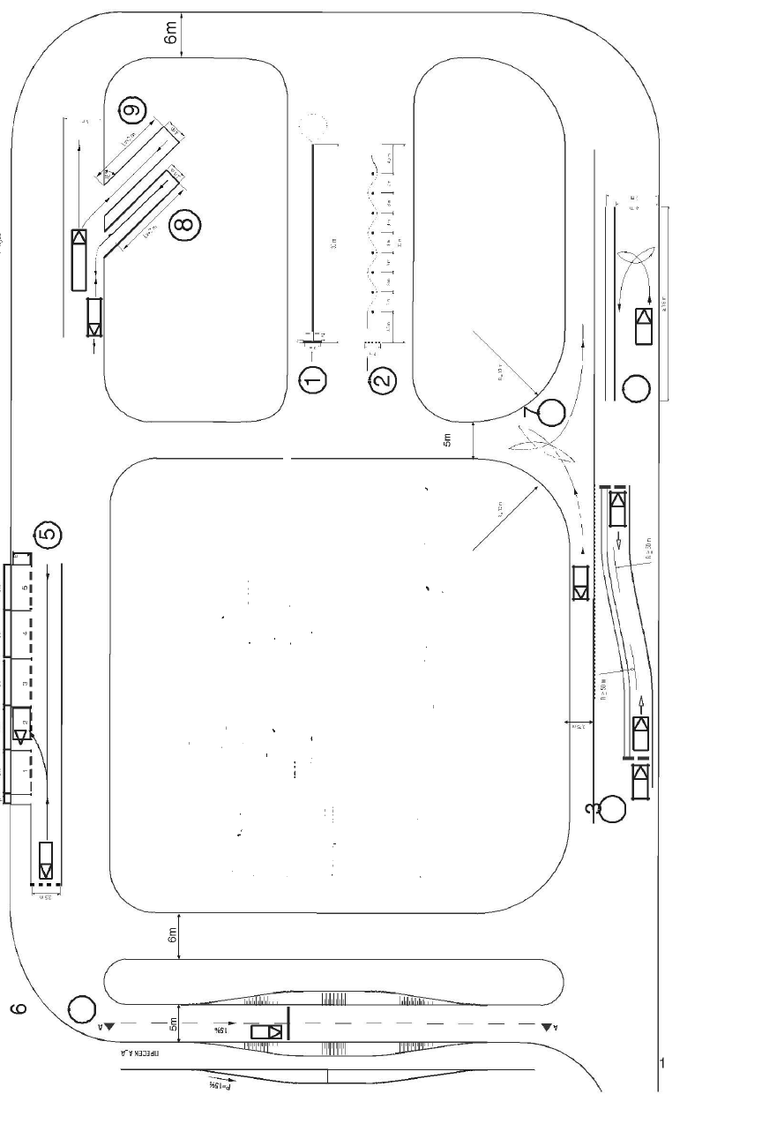





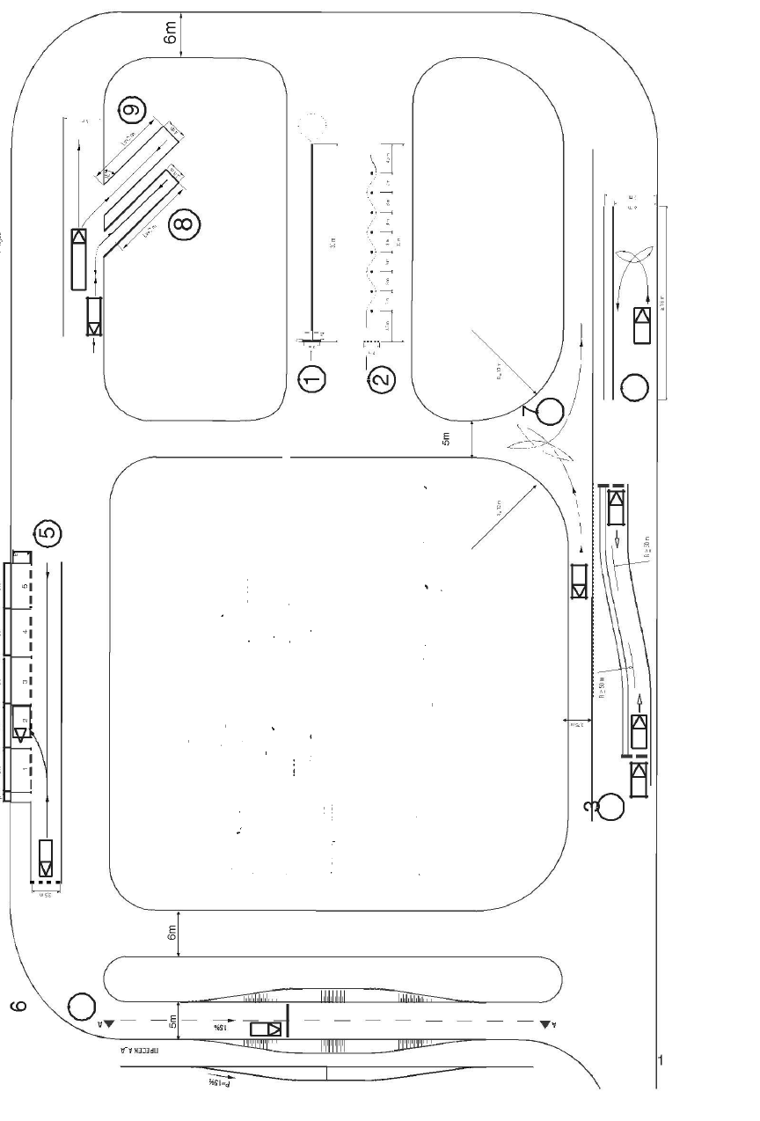





The horizontal marks (lines) of the traffic and technical elements of the autodrome are marked with white color and are 10 cm wide.

The length of the intermittent lines and the distance between them is 1 meter.

The number the parking space is marked with is with the following dimensions 40x20x6 cm.

The circle marking the location of the conus has 10 cm diameter.

The cone for the slalom drive drill is red and white.

Maneuver shall imply movement with the vehicle from one to another pose forward or backward.

The drills from A1, A2 and A category shall not overlap with the drills from the rest of the categories.

The drill number 3 displayed in Appendix 1- forward/ backward drive in lane for C1, C, D1 and national F categories may overlap with the same drill for B category and differ for the vertical outer line marked with yellow on a 1 meter distance.

Drill number 8 in Appendix 1 Diagonal backward parking for C1 and C categories and national F category may overlap with the drill number 9- Diagonal forward parking for D 1 and D categories and differ for the vertical outer line marked with yellow at a 25 cm distance.

MANNER OF SKILLING AND TAKING THE FOR PRACTICAL PART OF THE DRIVING EXAM FOR A1, A2 AND A CATEGORIES

Drill 1- item 1 from appendix 1

Moving from standstill, forward movement on marked straight line with length of 30 meters and width of 25 cm, with alteration from first to second gear, line exiting and return with free turn in second gear with stopping in a marked space with width of one meter with the front wheel in front of the stop line. The candidate shall step their foot on the road, set the gear in neutral, come off the motorcycle and push it forward from the exercise space.

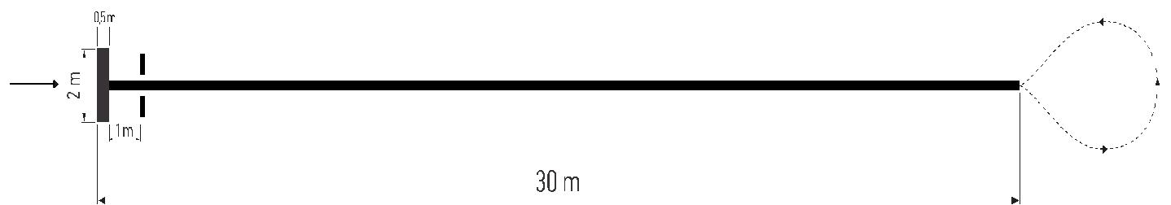

Slalom movement between eight cones with width of two meters and length of 30 meters.

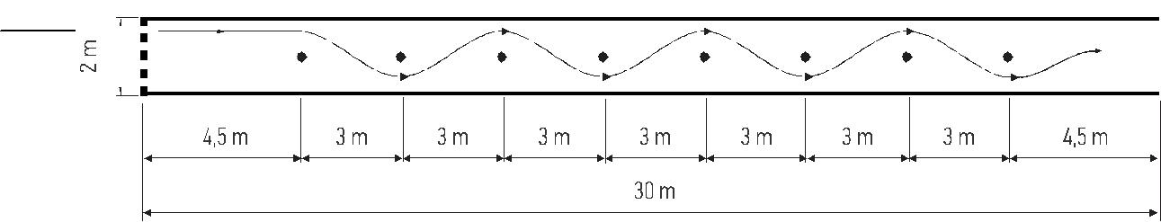

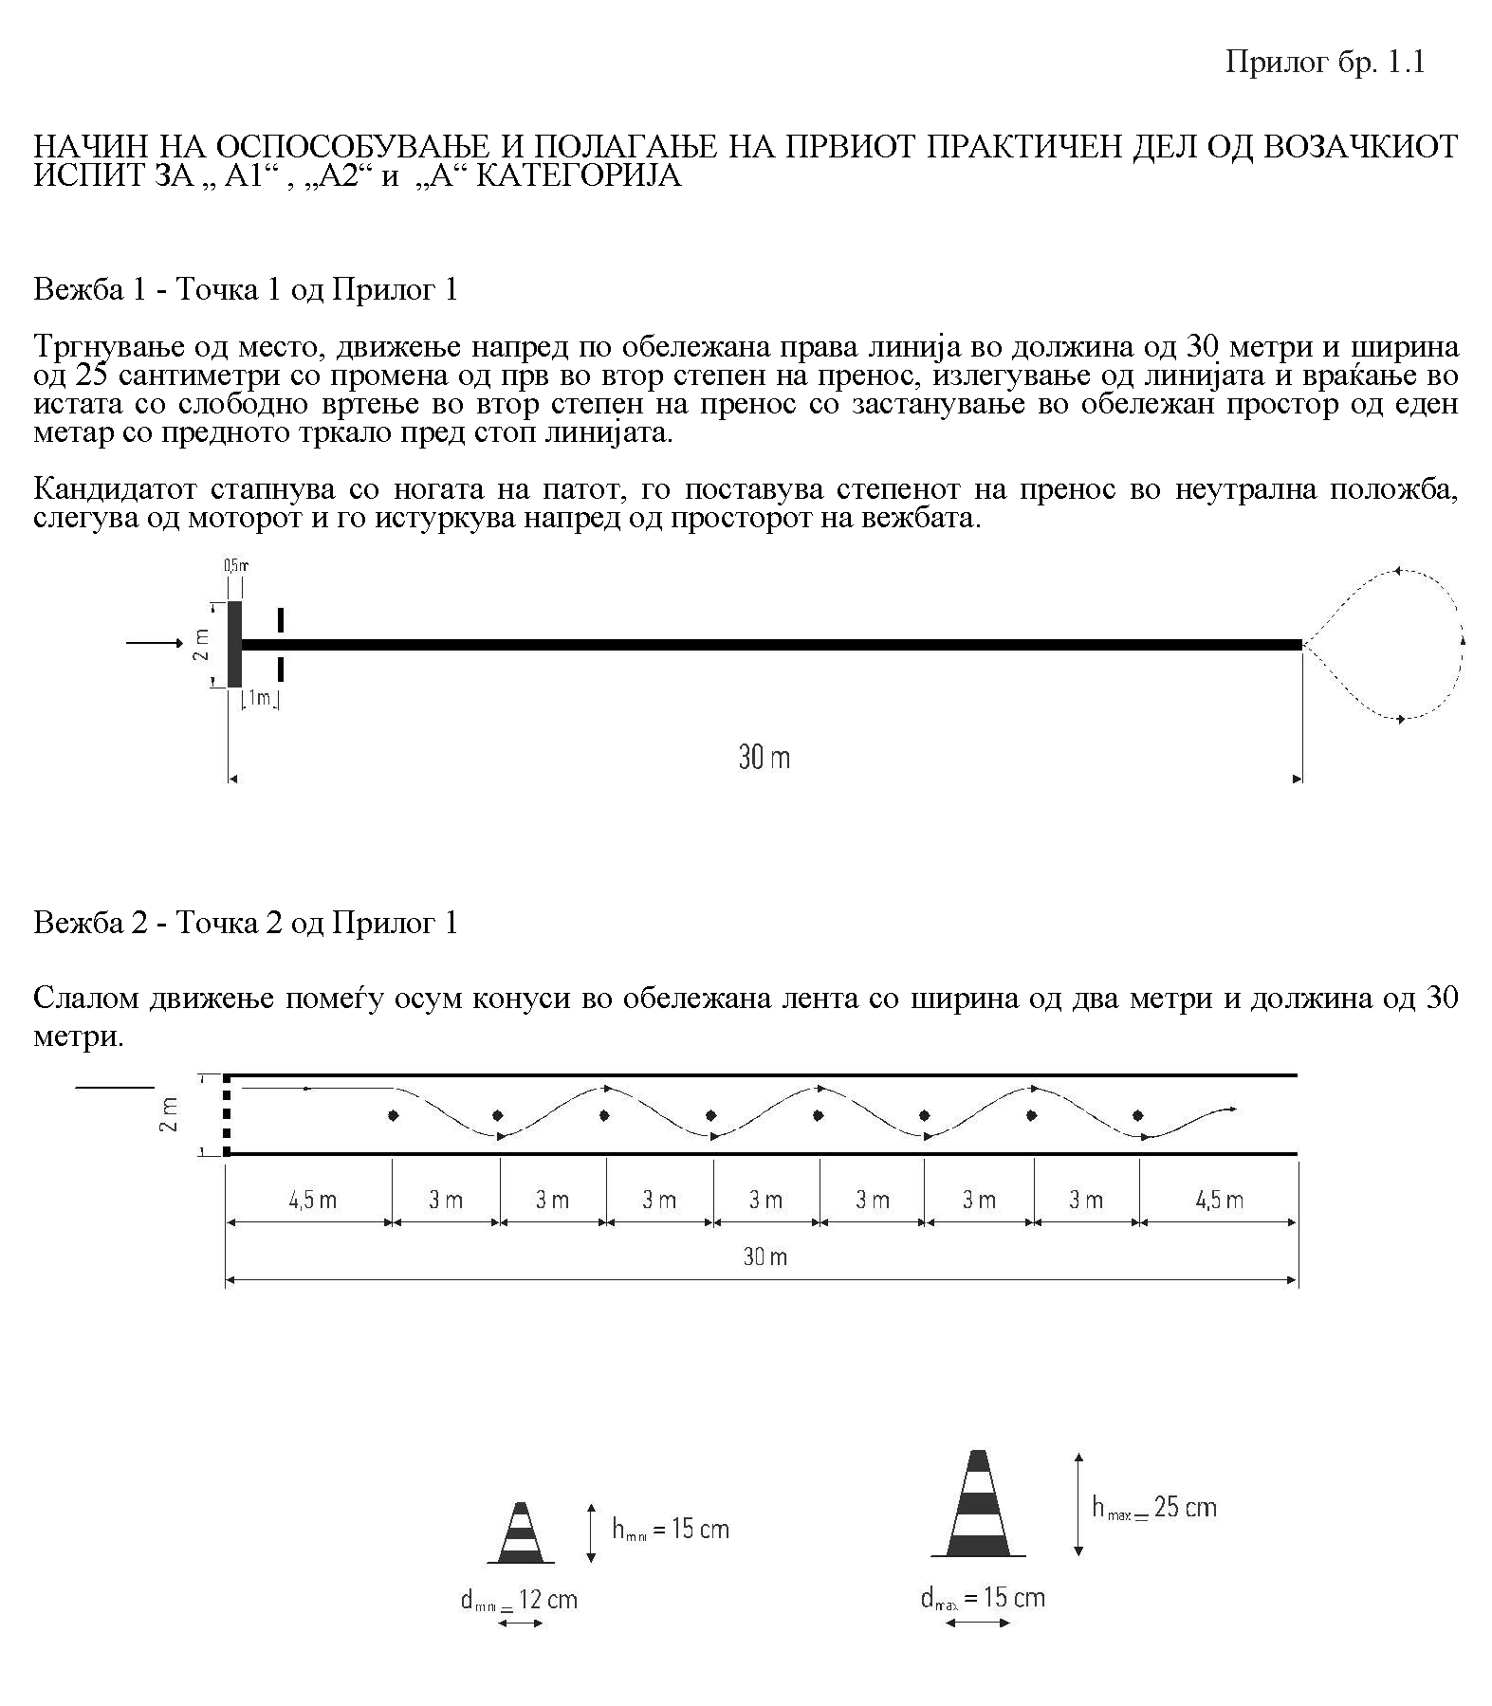



SKILLING MANNER AND EXAM TAKING FOR THE FIRST PRACTICAL PART OF THE DRIVING EXAM FOR B CATEGORY

Drill 1- item 3 from appendix number 1

For manual gearstick drill

Starting from standstill (position 1), forward movement in the traffic lane that is 2,5 meters wide and 36 meters long, shifting from first to second gear and stopping in front of the marked stop line (position 2). Backward movement on the same traffic lane stopping in front of the marked stopping line (position).

To exit the exercise one uses the same traffic lane for backward movement

II For automatic gear stick drill

Starting from standstill (position 1), forward movement in the traffic lane that is 2,5 meters wide and 36 meters long, shifting the automatic gear stick and stopping in front of the marked stop line (position 2). Backward movement on the same traffic lane stopping in front of the marked stopping line (position 3).

To exit the exercise one uses the same traffic lane for backward movement.

13 оD 51

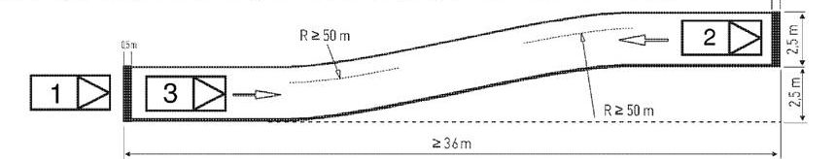

Drill 2- item 4 from appendix number 1

Semi- circular turn in a space that is six meters wide with three maneuvers for vehicles that are up to four meters long.

Semi- circular turn in a space that is seven meters wide with three maneuvers for vehicles that are over four meters long.

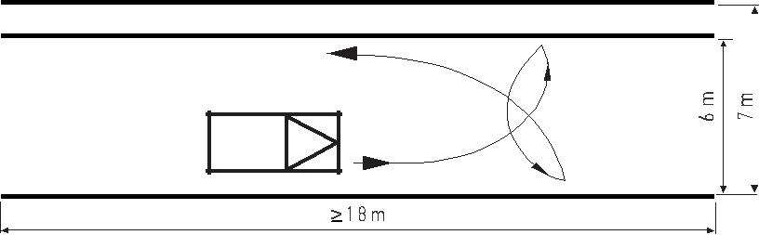

Exercise 3- item 5 from appendix number 1

Straight line parking by the edge of the road with backward movement in the space with dimensions:

Six meters long and two meters wide for vehicles that are up to four meters long and

Seven meters long and two meters wide for vehicles that are over four meters long.

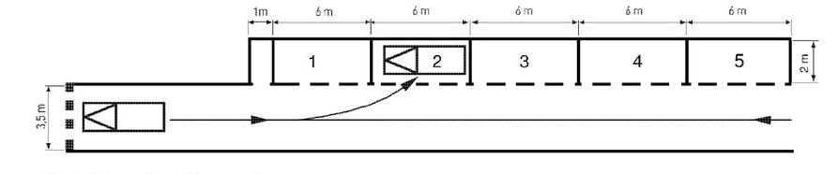

Exercise 4, item 6 from appendix number 1

Stopping and starting from in front of marked stop line on a steep road with an arch of 15% with hand gear stick.

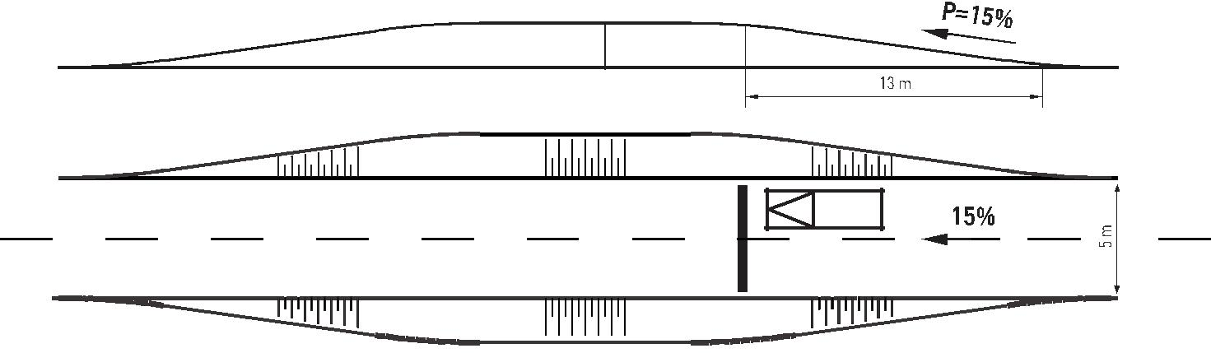

SKILLING MANNER AND EXAM TAKING FOR THE FIRST PRACTICAL PART OF THE DRIVING EXAM FOR C1, C, D1, D CATEGORY AND F NATIONAL CATEGORY

Drill 1- item 3 from appendix number 1

Starting from standstill (position 1), forward movement in the traffic lane that is 3,5 meters wide and 36 meters long, shifting from second to third gear and stopping in front of the marked stop line (position 2). Backward movement on the same traffic lane for stopping in front of the marked stopping line (position 3). To exit the exercise the same traffic lane is used with backward movement.

Exercise 2- item 7 from appendix number 1

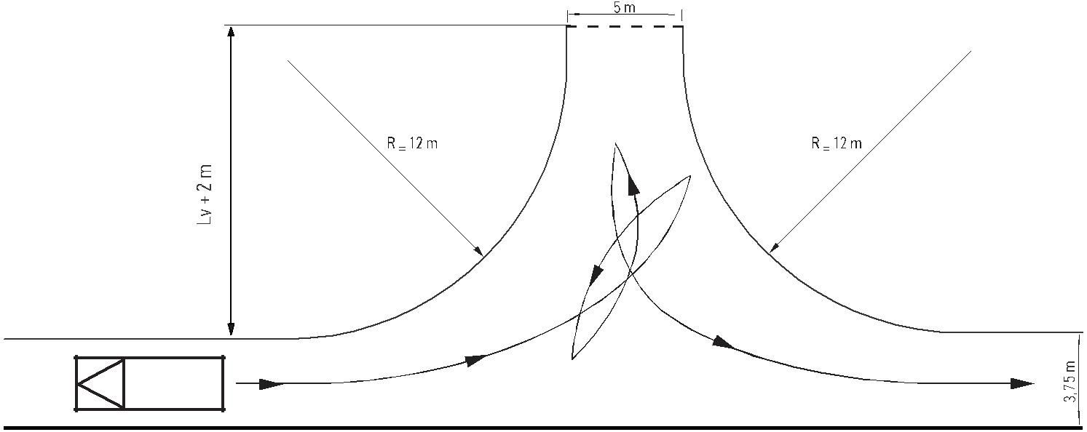Semi circular turn with use of a side road that is five meters wide with at most four maneuvers.

Exercise 3- item 8 from appendix number 1

Diagonal parking in 45 ( degrees) angle with backward movement in a space that is 3,75 meters wide for „C1“, „C“ category and „F“ national category.

Exercise 3- item 9 from appendix number 1

Diagonal parking with forward movement in a space that is four meters wide for „D1“ and „D“ category, exiting with inclusion in the traffic lane and forward movement.

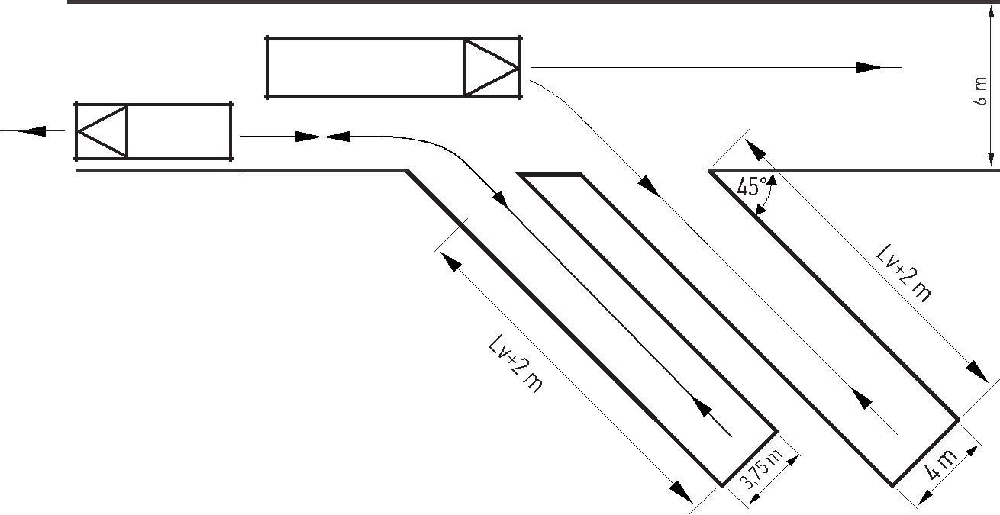

Exercise 6- item 6 from appendix number 1

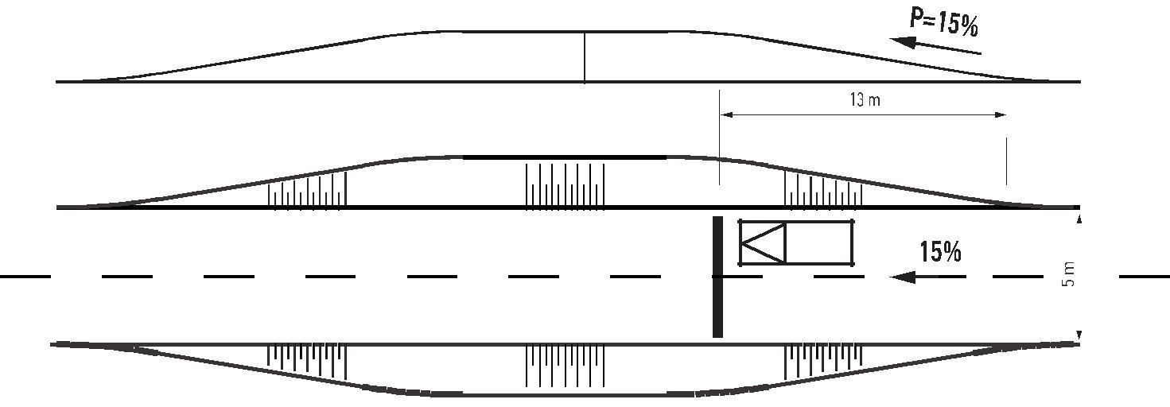Stopping and starting from in front of a marked stop line at a steep road with downward angle arch of 15% with hand gear stick

TEACHING PLAN AND PROGRAM FOR SKILLING OF DRIVER CANDIDATES FOR MOTOR VEHICLES FROM A1, A2, A, B, BE, C1, C1E, D1, D1E, D AND DE CATEGORIES

I THEORY PART

For skilling of driver candidates of motor vehicles from „А2“, „А1”, „А” and „B” category

А) GENERAL QUESTIONS – one class

Prescriptions on safety of traffic and roads

Meaning of certain terms used in the prescriptions from the area of the road traffic.

B) TRAFFIC SIGNS AND SIGNS GIVEN BY UNIFORMED POLICE OFFICERS- two classes

Term, role and meaning of the traffic signs for safe and diligent progress of the road traffic

Division of the traffic signs ( type, shape, color, meaning and setting)

Danger signs ( shape, color and meaning)

Direct order signs (group, shape, color and meaning)

Notification signs (shape, color and meaning)

Additional boards

Light traffic signs and light marks

Road demarcations (type and meaning)

Demarcation of a crossing point on a road across a railroad

Signs given by uniformed police officers while controlling and regulating the road traffic (type, manner of expression and meaning )

Signs given by vehicles with the right to surpass and accompanied vehicles

C) TRAFFIC RULES – 11 classes

General provision on the conduct of the road traffic participants

Actions with vehicle in traffic

Determination of conditions with vehicle in traffic

Inclusion in traffic with vehicle and

Change of the manner and moving direction with vehicle

Moving with vehicle on road

Side of movement

Moving with vehicle on a road with multiple lanes

Left or right turn

Semi- circular movement

Backward movement.

Speed of movement

Assessment of the traffic road conditions and adjustment of the vehicle moving speed and

Limitation of the vehicle moving speed

Turning

Surpassing advantage

On a left turn

In relation to the vehicles moving on railroad

On a road that has been marked with a sign as a road with surpassing advantage

On intersection of bike track or bike lane and

At an intersection.

Intersection traffic

Term and division of intersections

Adjustment of vehicle moving speed

Timely move due to left or right turn

Acting in accordance with the light traffic signs and signs given by uniformed traffic officers

Passing

Alternate vehicle passing through

Surpassing and circling

General surpassing and circling rules

Manner of surpassing and circling around vehicles, obstacles and other road objects.

Use of light warning signs

Stopping and parking

Manner and conditions for stopping and parking

Prohibition for stopping and parking

Parking on a parking lot.

13. Vehicle pull

14. Use of lights in traffic

Use of lights at night

Use of lights in day time and in conditions of decreased visibility and

Vision adaptation in uneven or sudden change of road light.

Space between vehicles

Tram traffic and traffic of other rail road vehicles

Bicycle traffic, tricycles and quadricycles, bicycle with auxiliary engine and mopeds, work machines, moto cultivators and wagons

Movement of livestock on the road

Movement of pedestrians on the road

Pedestrian movement rules

Driver behavior toward pedestrians

Interception of pedestrian column

Traffic on a crossing point across railroad

Motorway traffic and traffic on a road reserved for motor vehicle movement

Inclusion, movement manner, exclusion and

Criteria for movement of certain vehicle categories, limitation of speed of movement with a vehicle, manner of stopping and semi- circular turn.

Tunnel traffic

Traffic of accompanied vehicles, vehicles with right to surpassing advantage and the behavior toward them

Vehicle load

Accommodation and demarcation of load

Vehicle load transport

Vehicle passenger transport

Transport of passengers with auxiliary vehicle being pulled by a tractor or a moto cultivator

Sports and other road events

Vehicle night drive and under harsh weather conditions (low and high temperature, decreased visibility, snow, ice, wind, fog, sliding, rock falls).

D) DANGERS AND EFFECTS EMERGING DUE TO WRECK LESS AND INCORRECT ACTIONS IN THE ROAD TRAFFIC – one class

Unadjusted movement speed, with the vehicle, in accordance with the characteristics, visibility, atmospheric conditions, vehicle state and load, the traffic density and other traffic conditions

Wrong speed estimate and estimate of the space between the moving vehicles on the opposite side or in the same direction in front or behind the vehicle

Vehicle movement with disallowed speed in a populated location and outside one, and sudden increase and decrease of the vehicle moving speed

Disrespect of the surpassing advantage rules on an intersection or wrong estimate of the traffic situation for application of the rules for intersection surpass advantage

Disrespect of the regulations for vehicle side of movement

Surpassing and circling on a road with no sufficient space for safe and diligently surpass and circling (vehicle column, road works )

Surpassing of a vehicle coming close to a pedestrian cross point or stopped in front of it due to pedestrian passing through

Stopping and parking with a vehicle on a road in a curve and near a pass where the visibility is insufficient or stopping on a road at night with no sufficient demarcation and security

Traffic signs disrespect

Improper vehicle pulling

Improper use of lights

E) NEGATIVE INFLUENCE OF SOME FACTORS FOR THE ROAD TRAFFIC SAFETY – one class

Health condition for motor vehicle driving (acute and chronical diseases influencing the driver’s abilities for driving)

Disrupted physical and psychological characteristics significant for the ability to drive (vision, hearing, reflexes, balance, sensory perception, cognition, skill, emotion, reaction)

Alcohol and traffic safety (degree of inebriation and their negative impact over the physical and psychological skills, functions and driver behavior )

Fatigue and traffic safety (types of fatigue, duration and way of rest use)

Medication and drugs have negative impact on the traffic safety (harmful effects of certain medications and drugs on the physical and psychological abilities of the driver)

F) MOTOR DRIVE VEHICLE DRIVERS- one class

Conditions for motor vehicle driving (legal, medical physical and psychological)

Enabling of motor vehicle driver candidates

Acquiring of the motor vehicle drive right

Driver license

Motor vehicles categories for which driver license is issued

Driver license validity and continuation

New driver license issuance in the place of an expired or a lost one

Driver license confiscation

International driver license;

Translation and replacement of a foreign driver license

Trial drive and vehicles with trial plates

Driver responsibility

criminal

misdemeanor

Material.

G) MOTOR VEHICLES DEVICES AND EQUIPMENT SIGNIFICANT FOR THE ROAD TRAFFIC SAFETY – one class

significance for the technical correctness of the road traffic safety

responsibilities and conditions for motor vehicle registration

Technical examination of motor and auxiliary vehicles

Exclusion of a vehicle from the traffic

Removal of a defective vehicle

Motorcycle equipment (protective helmet, gloves, suit, reflexive vest)

Vehicle driving devices (role, type, functioning, prescribed conditions for regularity)

Stopping devices (role, types, functioning, prescribed conditions for regularity)

Devices for road lightning and giving light signs (role, other prescribed conditions)

Normal visibility devices ( role, types and other prescribed conditions)

Devices for merging a pulling and auxiliary vehicle (role and other prescribed conditions)

Vehicle tires (types and prescribed conditions)

Safety belts (role , meaning and manner of use) and

Passenger vehicles equipment.

H) HUMAN RELATIONSHIPS AND ETHICS OF TRAFFIC, SOLIDARITY TO THE OTHER TRAFFIC PARTICIPANTS – one class

Social norms (legal, traditional, moral, common) constructing the traffic ethics

Ethical and moral conduct, behavior and solidarity in the road traffic towards:

Other participants

Means of traffic

Roads and road objects

Traffic signs and the official persons regulating the road traffic and

Special treatment toward disabled persons, children, elderly and disabled people, persons with special needs, blind person etc.

I) DUTIES IN CASE OF TRAFFIC ACCIDENT AND SPECIAL SAFETY MEASURES- one class

For the participant in the traffic accident

For drivers and persons present or came across the traffic accident site

Competence for control and regulation of the road traffic and

Special authorizations for the official persons during control and regulation of road traffic.

J) CONCLUSIONS, DETERMINATION OF THE MATERIAL AND KNOWLEDGE EXAMINATION THROUGH TESTING- one class

The motor vehicle candidates from „А2“, „А1“and „А“ categories who do not possess B category driver license shall not be examined for the teaching content covered in this program such as:

Chapter C, item 3 indent 5 and items 12,13, 24 and 25;

Chapter D, items 8 and10;

Chapter G, items 10, 11,13 and 14.

The driver candidates for motor vehicles for „А2“, „А1“ and „А“who possess B category driver license shall be examine for the following:

Equipment for the motorcycle driver and the person transported;

Motorcycle driving manner (stance and body position, movement in traffic lane);

Transportation of passengers with motorcycle and

Dangers occurring during driving a motorcycle and stopping- stability loss due to gaps, ridges and other road elements, wet and slippery road, rock road and road made of other unstable material, curves etc.)

For skilling of driver candidates for motor vehicles from the „BE“, „C1", „C1Е“, „C“, „CЕ“, „D1“,„D1Е“, „D“, „DЕ“ categories

Dimensions, allowed sizes, shaft pressures and total mass of the load motor vehicles, busses and auxiliary vehicles

Specifications while transportation of load with motor and auxiliary vehicles

Accommodation and load fastening

Demarcation of the load exceeding the size capacity

Vehicle speed limit

Load transport necessary documentation.

Transportation of passengers with motor load vehicles

Transportation of passengers in the space intended for load transportation

Group passenger transport with and with no approval

Vehicle loading and vehicle driving right

Vehicle movement speed

Crew, time of vehicle driving, driving disruptions and time for the driver to rest

Daily and weekly vehicle driving time

Disruption of vehicle drive, daily and weekly rest for the driver

Manner of vehicle crew operation

Work time record and records of the rest and drive disruptions (tachograph and memory card).

Transportation of dangerous materials with load and auxiliary vehicles

Dangerous substances classification

Dangerous substances transportation conditions

Vehicle equipment and necessary driver equipment

Vehicles marking

Duties and responsibilities of the persons included in the transportation

Vehicle movement speed.

Trial drive

Extraordinary transportation

Devices and equipment prescribed for load motor vehicles, buses and auxiliary vehicles

Retarder role and functioning, role and functioning of the tachograph, merging device for a pull and auxiliary vehicle

Examination of the technical correctness of the vehicle and elimination of the possible fault

Prior to each use and

Preparation of the vehicle for its regular technical examination

Passenger transportation by bus

Conditions for performance of the road traffic

Transportation of passengers in internal and international traffic (line, free and transportation of passengers due to own needs ) and

Factors affecting the safety in passenger transportation

Transportation of people by bus

Conditions of transportation in the road traffic

Transportation of passengers in internal and international road traffic (line , free and transportation of passengers for own needs) and

Transportation of students and groups of children

Conditions that the vehicles need to meet (ABS, safety belts, fire extinguishers,

Auxiliary doors, roof openings etc.) and

Demarcation of the vehicles for transport of children with a special mark for children transportation

The driver candidates for motor vehicles from „C1“and „C“ categories shall be examined for the covered from item 1 to item 11 of this chapter;

The motor vehicles driver candidates from „D1“ and „D“ category shall be examined for the covered from item 1 to item 13 of this chapter;

The motor vehicle driver candidates from „BЕ“, „C1Е“, „CЕ“, „D1Е“, „DЕ“ categories shall be examined for the covered I items 8, 9, 10 and 11 from this chapter referring to the vehicle group.

The number of classes from the theory part for skilling of driver candidates is given in a tabular display and is an integral part of the program (appendix 2.1)

II. PRACTICAL PART

For skilling of the driver candidates for „А2“,„А1“ and „А“ category – 16 classes

INITIAL SKILLING

Knowledge of the vehicle with special stress of its main features, control and signal devices on the instrument board and adaptation of the driver mirrors;

Assuming of the seating position on the driving seat, knowledge of the technique and manner of body posture to maintain stability and trace while vehicle movement;

Change of degrees of transfer without motor operation;

Moving from standstill, forward movement on marked straight line with alteration from first to second gear, line exiting and return with free turn in second gear with maintenance of movement on short determined length and stopping in place.

Maintenance of movement direction while shifting from higher to a lower gear and vice- versa.

Movement on improvised intersections, left/ right turn on roads with and without horizontal and vertical signalization (executed within the conditions given by the polygon where the initial skilling is done)

Driving on improvised curves right and left in a road with determined length by vehicle movement in second gear.

Straight line movement on a marked straight line on a determined length with change from I to II gear and semi- circular turn in movement

Starting from standstill with a vehicle that is stopped on a road with higher arch and stopping

Starting from standstill, movement with a vehicle in 1 gear with alternate change of direction, left/ right on a determined length (slalom drive)

(B) SKILLING AT A PUBLIC ROAD OUTSIDE A POPULATED AREA AND PUBLIC ROAD INSIDE A POPULATED AREA

Driving on a road with a week traffic intensity, inclusion in traffic, side of movement, movement in a traffic lane alteration from a smaller to bigger gear and vice- versa by maintaining trace of movement with the vehicle, change of the trace of moment (change of traffic lane, left/ right turn ).

Driving on a road with no dense traffic, shifting to from smallest to biggest gear and maintenance of direction, proper stance of the driver in a curve and steep upward and downward road.

Driving along a street with dense traffic, passing, circling around, surpassing and giving warning signs to other participants in the traffic with the use of driving mirrors (rear view mirrors)

Driver actions following vehicle stop on intersection

Driving on intersection with same significance road crossing

Moving on intersection on a road that with a traffic sign has been marked as a road with passing advantage and a road where the traffic has been regulated with signs for expressive orders (mandatory stopping- stop sign and intersection with a road with passing advantage

Inclusion of vehicle on a road that has been marked as a road with passing advantage

Movement with a vehicle on an intersection with a traffic circle

Movement on an intersection where the traffic is especially regulated with devices for light signs (traffic light)

Manner of conduct on an intersection where the traffic has been regulated with slight signs upon appearance of permanent yellow light signal.

Moving on intersection where the traffic has been regulated with signs given by police officers

Actions with vehicle when coming across vehicles with passing advantage and accompanied vehicles

Driving on a road with dense traffic, keeping proper distance from the vehicle moving forward, passing by stopped vehicle for public transport of passengers on a bus station, passing by pedestrians and the behavior towards them

Approaching pedestrian crossing point and passing through pedestrians that have stepped or step at the moment on the pedestrian crossing point

Movement with a vehicle and use of sound and light signals when there are children with special needs by the road, elderly and disabled persons who do not pay attention to the vehicle

Driving during night time outside and inside populated area with the use of lights in line with the determine regime and conditions in the traffic with special exercising of passing and use of light signals for warning (blinking), passing by pedestrians and adjustment of the speed of movement according to the road conditions and traffic intensity

Driving inside and outside a populated area by practicing the actions or skills the candidate is not sufficiently skilled for.

For skilling of driver candidates for B category- 36 classes

INITIAL SKILLING

Knowledge of the vehicle the candidate is being trained for, with special stress to its main features;

External examination and control of the vehicle prior to the departure (tires, windows, devices etc.)

Entry in the vehicle, manner of opening and closing of the door of the vehicle, adjustment of the seat position to the driver body, manner of adjustment of driving mirrors, manner of safety belt tying, and familiarizing with the control and signal devices on the instrument board;

Shifting gears in place with no motor operation

Starting from standstill ,shifting from first to second gear with maintenance of the vehicle movement direction and stopping;

Starting from standstill ,shifting the gears with automatic gear stick with maintenance of the vehicle movement direction and stopping;

Maintenance of movement direction while shifting from higher to a lower gear and vice- versa.

Backward driving, maintenance of direction on determined length with use of the rear- view mirrors and straight line parking by the street edge in a determined space

Repetition and connection of the previous actions with the vehicle

Stopping the vehicle by the street edge by forward movement

Stopping the vehicle on a steep road, starting with use of auxiliary break

Movement on improvised intersections, left/ right turn on roads with and without horizontal and vertical signalization (executed within the conditions given by the polygon where the initial skilling is done)

Steering wheel operation during change of direction of vehicle movement, semi- circular turn without maneuvers on a wider space and with maneuvers on a limited space

Movement on improvised curves

Stopping and parking of the vehicle toward the right and left edge of the street on a spot intended for parking with forward movement, i.e. backward movement with use of light signals.

(B) SKILLING AT A PUBLIC ROAD OUTSIDE A POPULATED AREA AND PUBLIC ROAD INSIDE A POPULATED AREA

Driving on a road with a week traffic intensity, inclusion in traffic, side of movement, movement in a traffic lane alteration from a smaller to bigger gear and vice- versa by maintaining trace of movement with the vehicle, change of the trace of moment (change of traffic lane, left/ right turn ).

Driving on a road with a week traffic intensity, inclusion in traffic, side of movement, movement in a traffic lane alteration from a smaller to bigger gear and vice- versa by maintaining trace of movement with the vehicle, change of the trace of moment (change of traffic lane, left/ right turn ).

Driving on a road outside a populated area by keeping safe distance and shifting to from smallest to biggest gear and maintenance of direction, proper stance of the driver in a curve and steep upward and downward road, stopping and starting on an upward and downward road with the use of manual gear stick

Driving on a road outside a populated area with actions of the vehicle:

passing

circling

surpassing

passing by wagons and

passing by livestock moving outside the road

Driving through downward road, decreasing of the speed of movement or shifting from a higher to lower gear- engine stop and vehicle stop

Driving through downward road, decreasing of the speed of movement and vehicle stop

upward and downward road parking

Backward driving

Semi- circular turn of a vehicle without or with maneuvers, on a surface where public traffic progresses, correct movement of the gear stick during the action

Driving on a road with a week traffic intensity and adjusting the speed according to the road conditions and state

Driving along a street with no dense traffic, side of movement, right/ left turn, change of traffic lane with the use of driving mirrors (rear view mirrors)

Driving on a road across a crossing point for railroad.

Movement with a vehicle and use of sound and light signals when there are children with special needs by the road, elderly and disabled persons who do not pay attentiton to the vehicle

Move in front of an intersection with left/ right turn using the light signal devices and inclusion of the vehicle in the proper traffic lane from the side road.

Approaching pedestrian crossing point and passing through pedestrians that have stepped or step at the moment on the pedestrian crossing point

Turning the vehicle on a side road on the entrance of which there is no marked pedestrian crossing point and passing of pedestrians that have already stepped on the road

Movement on a wet road with special attention to the pedestrians by it

Movement by a public transportation vehicle that has stopped on a station when the persons go in and come out of it or go across the road

Adjusting movement speed,with the vehicle, in accordance with the characteristics, visibility, atmospheric conditions, the traffic density and other traffic conditions

Adjusting movement speed according to the traffic regime and the set road traffic signalization

Move in front of an intersection with left/ right turn (proper turning arch), inclusion of the vehicle in the proper traffic lane from the side road with or without vertical and horizontal road signalization.

Driver behavior after stopping the vehicle in front of and intersection.

Driving on intersection with same significance road crossing

Moving on intersection on a road that with a traffic sign has been marked as a road with passing adventage and a road where the traffic has been regulated with signs for expressive orders (mandatory stopping- stop sign and intersection with a road with passing adventage)

Inclusion of a vehicle on a road that has been marked as a road with passing advantage

Movement with a vehicle on an intersection with a traffic circle

Movement on an intersection where the traffic is especially regulated with devices for light signs (traffic light)

Manner of conduct on an intersection where the traffic has been regulated with light signs upon appearance of permanent yellow light signal.

Moving on intersection where the traffic has been regulated with signs given by police officers

Actions with vehicle when coming across vehicles with passing advantage and accompanied vehicles

Moving on road where there is alternating passing through of vehicles due to road work

Driving along a street with dense traffic and adjustment of the speed and manner of movement of the vehicle in line with the particular traffic conditions

Driving along a street with dense traffic, passing, circling around, surpassing and giving warning signs to the other participants in the traffic with the use of driving mirrors (rear view mirrors)

Stopping and parking

Inclusion in a public road traffic (exiting a parking lot, yard or another surface)

Driving autiside and inside populated area with the use of lights in line with the determine regime and conditions in the traffic with special exercising of passing and use of light signals for warning (blinking), passing by pedestrians and adjustment of the speed of movement according to the road conditions and traffic intensity

Driving autiside and inside populated area with the use of lights in line with the determine regime according to the horizontal, vertical and light signalization, the features and state of the road (wet road or ice), wheather obstacles (fog, rain, snow), traffic density and other traffic inconveniences.

Driving inside a populated area and outside it by practicing those actions or skills for which the candidate is not sufficiently skilled.

For skilling of driver candidates for motor vehicles with manual gearstick the following contents covered in this program shall not apply

Chapter A, item 6

Chapter B, item 2

For skilling of driver candidates for motor vehicles with automatic gearstick the following contents covered in this program shall not apply

Chapter A, items 5 and 7

Chapter B, items 1 and 4

For skilling of candidates for C1 and C categories- 20 classes

INITIAL SKILLING

Knowledge of the vehicle the candidate is being trained for, with special stress to its main features;

External examination and control of the vehicle prior to the departure (tires, windows, devices etc.)

Entry in the vehicle, manner of opening and closing of the door of the vehicle, adjustment of the seat position to the driver body, manner of adjustment of driving mirrors, manner of safety belt tying, and familiarizing with the control and signal devices on the instrument board;

Shifting gears in place with no motor operation

Starting from standstill ,shifting from first to second gear with maintenance of the vehicle movement direction and stopping;

Maintenance of movement direction while shifting from higher to a lower gear and vice- versa.

Backward driving, maintenance of direction on determined length with use of the rear- view mirrors and straight line parking by the street edge in a determined space

Stopping the vehicle on a steep road, starting with use of auxiliary break

Movement on improvised intersections, left/ right turn on roads with and without horizontal and vertical signalization (executed within the conditions given by the polygon where the initial skilling is done)

Stopping and parking of the vehicle toward the right and left edge of the street on a spot intended for parking with forward movement, i.e. backward movement with use of light signals.

(B) SKILLING AT A PUBLIC ROAD OUTSIDE A POPULATED AREA AND PUBLIC ROAD INSIDE A POPULATED AREA

Driving on a road with a week traffic intensity, inclusion in traffic, side of movement, movement in a traffic lane alteration from a smaller to bigger gear and vice- versa by maintaining trace of movement with the vehicle, change of the trace of moment (change of traffic lane, left/ right turn ).

Driving on a road outside a populated area, passing, circling, surpassing and giving warning signs.

Driving on a road outside a populated area by keeping safe distance and shifting to from smallest to biggest gear and maintenance of direction, proper stance of the driver in a curve and steep upward and downward road, stopping and starting on an upward and downward road with the use of manual gear stick

Driving through downward road, decreasing of the speed of movement or shifting from a higher to lower gear- engine stop and vehicle stop

upward and downward road parking

Upward backward driving

Driving inside a populated area on a road with week density, side of movement, change of direction, use of rear view mirrors (left/ right turn, traffic lane change

Adjusting movement speed,with the vehicle, in accordance with the characteristics, visibility, atmospheric conditionbs, the traffic density and other traffic conditions

Semi- circular turn of a vehicle without or with maneuvers, on a surface where public traffic progresses

Driving inside a populated area on a road with dense traffic, passing, circling, surpassing and lane switching in front of an intersection with left/ right turn with use of rear view mirrors

Movement of the vehicle on a street with marked pedestrian crossing point and use of sound and light signs when there are children by the road or persons with special needs, older and disabled persons not paying attention to the vehicle.

Entry in and exit from a parking lot or another surface where public traffic does not progress

Moving on intersection (regulated and not regulated)

Driving during night time outiside and inside populated area with the use of lights in line with the determined regime and conditions in the traffic with special exercising of passing and use of light signals for warning (blinking), passing by pedestrians.

For skilling of the driver candidates for „D1“ and „D“ category- 16 classes

The the driver candidates for „D1“ and „D“ category shall be skilled according to the contents in the chapter for enabling driver candidates for „C1“ and „C“ category and the following additional materials for examination of the knowledge of the driver candidates:

1.Entering in and exiting from a bus station

2. Entering in and exiting from a bus terminal

For skilling of the driver candidates for „BЕ“,„CЕ“, „C1Е“,„DЕ“, „D1Е“ category

The driver candidates for the stated categories shall be skilled according to the contents in the chapter for enabling driver candidates for „B“, „C1“, „C“, „D1“ and „D“ category, -Chapter B, characteristic for the navigation of a group of vehicles as well as the additional materials on the manner and procedure of turning on and off a:

1.merging device of a pull and auxiliary vehicle

2.Demarcation and light signaling device

3.Device for transmission of air in the auxiliary vehicle stop system

1. REGULATIONS ON THE ROAD TRAFFIC SAFETY

A) TRAFFIC RULES- SEVEN CLASSES

General provision on the conduct of the road traffic participants

Actions with vehicle in traffic

Determination of conditions with vehicle in traffic

Inclusion in traffic with vehicle and

Change of the manner and moving direction with vehicle

3. Moving with vehicle on road

Side of movement

Moving with vehicle on a road with multiple lanes

Left or right turn

Semi- circular movement

Backward movement.

4.Speed of movement

Assessment of the traffic road conditions and adjustment of the vehicle moving speed and

Limitation of the vehicle moving speed

5.Turning

6.Surpassing advantage

On a left turn

In relation to the vehicles moving on railroad

On a road that has been marked with a sign as a road with surpassing advantage

On interception of bike track or bike lane and

At an intersection.

7.Intersection traffic

Term and division of intersections

Adjustment of vehicle moving speed

Timely move due to left or right turn

Acting in accordance with the light traffic signs and signs given by uniformed traffic officers

8 Passing

9 Alternate vehicle passing through

10 Surpassing and circling

General surpassing and circling rules

Manner of surpassing and circling around vehicles, obstacles and other road objects.

11 Use of light warning signs

12 Stopping and parking

Manner and conditions for stopping and parking

Prohibition for stopping and parking

Parking on a parking lot.

13. Vehicle pull

14. Use of lights in traffic

Use of lights at night

Use of lights in day time and in conditions of decreased visibility and

Vision adaptation in uneven or sudden change of road light.

Space between vehicles

Bicycle traffic, tricycles and quadricycles, bicycle with auxiliary engine and mopeds, work machines, moto cultivators and wagons

Movement of pedestrians on the road

Pedestrian movement rules

Driver behavior toward pedestrians

Interception of pedestrian column

Traffic on a crossing point across railroad

Traffic of accompanied vehicles, vehicles with right to surpassing advantage and the behavior toward them

Load transportation with an auxiliary vehicle being pulled by tractor and moto cultivator

Load placement and marking

Vehicle passenger transport

Transport of passengers with auxiliary vehicle being pulled by a tractor or a moto cultivator

Vehicle night drive and under harsh weather conditions (low and high temperature, decreased visibility, snow, ice, wind, fog, sliding, rock falls).

B) TRAFFIC SIGNS AND SIGNS GIVEN BY UNIFORMED POLICE OFFICERS- two classes

Term, role and meaning of the traffic signs for safe and diligent progress of the road traffic

Division of the traffic signs ( type, shape, color, meaning and setting)

Danger signs ( shape, color and meaning)

Direct order signs (group, shape, color and meaning)

Notification signs (shape, color and meaning)

Additional boards

Light traffic signs and light marks

Road demarcations (type and meaning)

Demarcation of a crossing point on a road across a railroad

Signs given by uniformed police officers while controlling and regulating the road traffic (type, manner of expression and meaning )

Signs given by vehicles with the right to surpass and accompanied vehicles

C) DANGERS AND EFFECTS EMERGING DUE TO WRECK LESS AND INCORRECT ACTIONS IN THE ROAD TRAFFIC – two classes

Unadjusted movement speed, with the vehicle, in accordance with the characteristics, visibility, atmospheric conditions, vehicle state and load, the traffic density and other traffic conditions

Wrong speed estimate and estimate of the space between the moving vehicles on the opposite side or in the same direction in front or behind the vehicle

Vehicle movement with disallowed speed in a populated location and outside one, and sudden increase and decrease of the vehicle moving speed

Disrespect of the surpassing advantage rules on an intersection or wrong estimate of the traffic situation for application of the rules for intersection surpass advantage

Disrespect of the regulations for vehicle side of movement

Surpassing and circling on a road with no sufficient space for safe and diligently surpass and circling (vehicle column, road works )

Surpassing of a vehicle coming close to a pedestrian cross point or stopped in front of it due to pedestrian passing through

Stopping and parking with a vehicle on a road in a curve and near a pass where the visibility is insufficient or stopping on a road at night with no sufficient demarcation and security

Traffic signs disrespect

Improper use of lights

D) BASES ON THE FUNCTIONING OF THE DEVICES OF THE MOTOR DRIVE VEHICLES, SIGNIFICANT FOR THE ROAD TRAFFIC SAFETY- one class

The motor vehicle drive candidates for national F category shall not be skilled in the following contents covered in this program:

Chapter A, items 16 and 21

The drive candidates for bicycle with auxiliary engine and moped shall not be skilled in the following contents covered in this program:

Chapter A, item 3, indent 5, items 12, 13, 20 and 22

Chapter B, item 8

II PRACTICAL PART

For skilling of candidates for tractor navigation- 12 classes

INITIAL SKILLING

Knowledge of the vehicle the candidate is being trained for, with special stress to its main features;

External examination and control of the vehicle prior to the departure (tires, windows, devices etc.)

Entry in the vehicle, manner of opening and closing of the door of the vehicle, adjustment of the seat position to the driver body, manner of adjustment of driving mirrors, manner of safety belt tying, and familiarizing with the control and signal devices on the instrument board;

Shifting gears in place with no motor operation

Starting from standstill ,shifting from first to second gear with maintenance of the vehicle movement direction and stopping;

Maintenance of movement direction while shifting from higher to a lower gear and vice- versa.

Backward driving, maintenance of direction on determined length with use of the rear- view mirrors and straight line parking by the street edge in a determined space

Stopping the vehicle on a steep road, starting with use of auxiliary break

Stopping the vehicle by the street edge by forward movement

Movement on improvised intersections, left/ right turn on roads with and without horizontal and vertical signalization (executed within the conditions given by the polygon where the initial skilling is done)

Steering wheel operation during change of direction of vehicle movement, semi- circular turn without maneuvers on a wider space and with maneuvers on a limited space

Movement on improvised curves

Stopping and parking of the vehicle toward the right and left edge of the street on a spot intended for parking with forward movement, i.e. backward movement with use of light signals.

SKILLING AT A PUBLIC ROAD OUTSIDE A POPULATED AREA AND PUBLIC ROAD INSIDE A POPULATED AREA

Driving on a road with a week traffic intensity, inclusion in traffic, side of movement, movement in a traffic lane alteration from a smaller to bigger gear and vice- versa by maintaining trace of movement with the vehicle, change of the trace of moment (change of traffic lane, left/ right turn).

Driving on a road outside a populated area by keeping safe distance and shifting to from smallest to biggest gear and maintenance of direction, proper stance of the driver in a curve and steep upward and downward road, stopping and starting on an upward and downward road with the use of manual gear stick

Driving on a road outside a populated area with actions of the vehicle:

Passing

circling

surpassing

passing by wagons and

passing by livestock moving outside the road

Driving through downward road, deceasing of the speed of movement or shifting from a higher to lower gear- engine stop and vehicle stop

upward and downward road parking

Backward driving

Semi- circular turn of a vehicle without or with maneuvers, on a surface where public traffic progresses, correct movement of the gear stick during the action

Driving on a road with a week traffic intensity and adjusting the speed according to the road conditions and state

Driving along a street woth no dense traffic, passing, side of movement, right/ left turn, change of traffic lane with the use of driving mirrors (rear view mirrors)

Driving on a road across a crossing point for railroad.

Movement with a vehicle and use of sound and light signals when there are children with special needs by the road, elderly and disabled persons who do not pay attentiton to the vehicle

Move in front of an intersection with left/ right turn using the light signal devices and inclusion of the vehicle in the proper traffic lane from the side road.

Approaching pedestrian crossing point and passing through pedestrians that have stepped or step at the moment on the pedestrian crossing point

Turning the vehicle on a side road on the entrance of which there is no marked pedestrian crossing point and passing of pedestrians that have already stepped on the road

Movement on a wet road with special attention to the pedestrians by it

Movement by a public transportation vehicle that has stopped on a station when the persons go in and come out of it or go across the road

Adjusting movement speed,with the vehicle, in accordance with the characteristics, visibility, atmospheric conditions, the traffic density and other traffic conditions

Adjusting movement speed according to the traffic regime and the set road traffic signalization

Move in front of an intersection with left/ right turn (proper turning arch), inclusion of the vehicle in the proper traffic lane from the side road with or without vertical and horizontal road signalization.

Driver behavior after stopping the vehicle in front of and intersection.

Driving on intersection with same significance road crossing

Moving on intersection on a road that with a traffic sign has been marked as a road with passing adventage and a road where the traffic has been reguylated with signs for expressive orders (mandatory stopping- stop sign and intersection with a road with passing adventage)

Inclusion of a vehicle on a road that has been marked as a road with passing advantage

Movement with a vehicle on an intersection with a traffic circle

Movemwent on a intersection where the traffic is especially regulated with devices for light signs (traffic light)

Manner of conduct on an intersection where the traffic has been regulated with slight signs upon appearance of permanent yellow light signal.

Moving on intersection where the traffic has been regulated with signs given by police officers

Actions with vehicle when coming across vehicles with passing advantage and accompanied vehicles

Moving on road where there is alternating passing through of vehicles due to road work

Driving along a street with dense traffic and adjustment of the speed and manner of movement of the vehicle in line with the particular traffic conditions

Driving along a street woth dense traffic, passing, circling around, surpassing and giving warning signs to othe other participants in the traffic with the use of driving mirrors (rear view mirrors)

Stopping and parking

Inclusion in a public road traffic (exiting a parking lot, yard or another surface)

Driving outiside and inside populated area with the use of lights in line with the determined regime and conditions in the traffic with special exercising of passing and use of light signals for warning (blinking), passing by pedestrians and adjustment of the speed of movement according to the road conditions and traffic intensity

Driving autiside and inside populated area with the use of lights in line with the determine regime according to the horizontal, vertical and light signalization, the features and state of the road (wet road or ice), weather obstacles (fog, rain, snow), traffic density and other traffic inconveniences.

Driving inside a populated area and outside it by practicing those actions or skills for which the candidate is not sufficiently skilled

The candidates for bicycle with auxiliary engine and moped shall not be skilled for the following contents covered with this program:

Chapter A, items 3,7,10 and 14

Chapter B, item 2 (use of auxiliary break) items 4,5,6 and 32

Appendix number 3

Driver candidates record keeping book

|  |  |  |  |  |  |  |  |
| --- | --- | --- | --- | --- | --- | --- | --- |
| Ordinal number | Name, name of one parent and surname | Date and place of birth | Residence/ temporary residence, address | Category for which the candidate is skilled | Number, place and date of certificate issuance and the physical and psychological ability for motor vehicle navigation | Part of the program the skilling is carried out for | Number and date of issued certificate for theory education |
| Theory |
|  |  |  |  |  |  |  |  |
|  |
|  |  |  |  |  |  |  |  |
|  |
|  |  |  |  |  |  |  |  |
|  |
|  |  |  |  |  |  |  |  |
|  |
|  |  |  |  |  |  |  |  |
|  |
|  |  |  |  |  |  |  |  |
|  |
|  |  |  |  |  |  |  |  |
|  |
|  |  |  |  |  |  |  |  |
|  |
|  |  |  |  |  |  |  |  |
|  |

Driver candidates record keeping book

|  |  |  |  |  |  |  |  |
| --- | --- | --- | --- | --- | --- | --- | --- |
| Number of held classes | Date of the trial test | Number and date of the issued certificate from the examination of the knowledge of the traffic and road rules and traffic signs  (trial test) | Part of the program for which the skilling is carried out | Number of held classes | Date of the issued skilling certificate | Name and surname of the instructor that performs the skilling  Data on the successfulness of the candidate on the driving exam | Note |
| Practical |
|  |  |  |  |  |  |  |  |
|  |  |  |  |  |  |  |  |
|  |  |  |  |  |  |  |  |
|  |  |  |  |  |  |  |  |
|  |  |  |  |  |  |  |  |
|  |  |  |  |  |  |  |  |
|  |  |  |  |  |  |  |  |

Appendix number 3.1

Driver candidates record keeping book for additional skilling

|  |  |  |  |  |  |  |  |  |  |
| --- | --- | --- | --- | --- | --- | --- | --- | --- | --- |
| Ordinal number | Name, name of one parent and surname | Date and place of birth | Residence/ temporary residence, address | Category for which the candidate is skilled | Part of the program the skilling is carried out for | Number of held classes | Time in which the classes were held | Name and surname of the instructor | note |
|  |  |  |  |  |  |  |  |  |  |
|  |
|  |  |  |  |  |  |  |  |  |  |
|  |
|  |  |  |  |  |  |  |  |  |  |
|  |
|  |  |  |  |  |  |  |  |  |  |
|  |
|  |  |  |  |  |  |  |  |  |  |
|  |
|  |  |  |  |  |  |  |  |  |  |
|  |
|  |  |  |  |  |  |  |  |  |  |
|  |
|  |  |  |  |  |  |  |  |  |  |
|  |
|  |  |  |  |  |  |  |  |  |  |
|  |
|  |  |  |  |  |  |  |  |  |  |
|  |
|  |  |  |  |  |  |  |  |  |  |
|  |
|  |  |  |  |  |  |  |  |  |  |
|  |
|  |  |  |  |  |  |  |  |  |  |
|  |
|  |  |  |  |  |  |  |  |  |  |
|  |

Appendix number 3.2

Record keeping journal of the performed theory part of the program for skilling the driver candidates

|  |  |  |  |  |  |  |  |
| --- | --- | --- | --- | --- | --- | --- | --- |
| Number under which the candidate is recorded in the main book | Date of the held education | Category for which the skilling is done | Subject being taught and the lesson | Name and surname of the educator | Name and surname of the candidate that attended the education | Signature | Note |
|  |  |  |  |  |  |  |  |
|  |
|  |  |  |  |  |  |  |  |
|  |
|  |  |  |  |  |  |  |  |
|  |
|  |  |  |  |  |  |  |  |
|  |
|  |  |  |  |  |  |  |  |
|  |
|  |  |  |  |  |  |  |  |
|  |
|  |  |  |  |  |  |  |  |
|  |
|  |  |  |  |  |  |  |  |
|  |
|  |  |  |  |  |  |  |  |
|  |
|  |  |  |  |  |  |  |  |
|  |
|  |  |  |  |  |  |  |  |
|  |

Appendix number 3.3

|  |  |  |
| --- | --- | --- |
| Name of the legal person |  | unique personal number |
| Driver instructor | ___________________ | No. _______________ |
| Driver instructor | ___________________ | No. _______________ |
|  |  |  |
|  | CHART  for record keeping of the skilling of a driver candidate for the practical part of the program |  |
|  | Category __________ |  |
| Name and surname | ________________ |  |
| Born | ________________ | in __________________ |
| Telephone | _____________________ |  |
| Health certificate | No. _______ | from______________ |
| Vehicle | Type ________________ |  |
|  | Brand _______________ |  |
|  | Registration labels________________ |  |
|  | Ownership ____________________ |  |
| Date _____20____ | Place for seal | Competent manager  __________________ |

|  |  |  |  |  |  |  |  |
| --- | --- | --- | --- | --- | --- | --- | --- |
| date | Operation description | | Skilling time | | Class number | Candidate signature | Instructor signature |
|  | chapter | location | from  (hour) | to  (hour) |
|  | lesson |
|  |  |  |  | |  |  |  |
|  |  |  |  | |  |  |  |
|  |  |  |  | |  |  |  |
|  |  |  |  | |  |  |  |
|  |  |  |  | |  |  |  |
|  |  |  |  | |  |  |  |
|  |  |  |  | |  |  |  |
|  |  |  |  | |  |  |  |
|  |  |  |  | |  |  |  |
|  |  |  |  | |  |  |  |
|  |  |  |  | |  |  |  |
|  |  |  |  | |  |  |  |
|  |  |  |  | |  |  |  |
|  |  |  |  | |  |  |  |
|  |  |  |  | |  |  |  |
|  |  |  |  | |  |  |  |
|  |  |  |  | |  |  |  |
|  |  |  |  | |  |  |  |
|  |  |  |  | |  |  |  |
|  |  |  |  | |  |  |  |
|  |  |  |  | |  |  |  |
|  |  |  |  | |  |  |  |
|  |  |  |  | |  |  |  |
|  |  |  |  | |  |  |  |
|  |  |  |  | |  |  |  |
|  |  |  |  | |  |  |  |
|  |  |  |  | |  |  |  |
|  |  |  |  | |  |  |  |
|  |  |  |  | |  |  |  |
|  |  |  |  | |  |  |  |
|  |  |  |  | |  |  |  |
|  |  |  |  | |  |  |  |
|  |  |  |  | |  |  |  |
|  |  |  |  | |  |  |  |

|  |  |  |  |  |  |  |  |
| --- | --- | --- | --- | --- | --- | --- | --- |
| date | Operation description | | Skilling time | | Class number | Candidate signature | Instructor signature |
|  | chapter | location | from  (hour) | to  (hour) |
|  | lesson |
|  |  |  |  | |  |  |  |
|  |  |  |  | |  |  |  |
|  |  |  |  | |  |  |  |
|  |  |  |  | |  |  |  |
|  |  |  |  | |  |  |  |

Instructor opinion: The driver candidate with performed _________ classes

Is ready to take the exam

Is not ready to take the exam and further skilling in the chapter _______, items ______ needs to be done;

Signature of the driver- instructor____________

NOTES FOR THE DRIVER CANDIDATE

|  |
| --- |
|  |
|  |
|  |
|  |
|  |
|  |
|  |

15 оD 51

THE NUMBER OF THE PRACTICAL CLASSES FROM THE PROGRAM FOR SKILLING MOTOR VEHICLES AND TRACTOR DRIVER CANDIDATES FOR THE FOLLOWING CATEGORIES SHALL BE:

|  |  |
| --- | --- |
| A2 category | 16 classes |
| A1 category | 16 classes |
| A category | 16 classes |
| B category | 36 classes |
| BE category | 8 classes |
| C1 category | 20 classes |
| C1E category | 8 classes |
| C category | 20 classes |
| CE category | 8 classes |
| D1 category | 16 classes |
| D1E category | 8 classes |
| D category | 16 classes |
| DE category | 8 classes |
| F category | 12 classes |

|  |  |
| --- | --- |
| acquired C1, being skilled for C | 4 classes |
| acquired C1E, being skilled for CE | 4 classes |
| acquired D1, being skilled for D | 4 classes |
| acquired D1E, being skilled for DE | 4 classes |
| acquired F, being skilled for B | 24 classes |

Appendix 3.4

|  |  |  |
| --- | --- | --- |
| Name of the legal person |  | unique personal number |
| Driver instructor | ___________________ | No. _______________ |
| Driver instructor | ___________________ | No. _______________ |
|  |  |  |
|  | CHART  for record keeping of the additional skilling of a driver candidate for the practical part of the program |  |
|  | Category __________ |  |
| Name and surname | ________________ |  |
| Born | ________________ | in __________________ |
| Telephone | _____________________ |  |
| Health certificate | No. _______ | from______________ |
| Vehicle | Type ________________ |  |
|  | Brand _______________ |  |
|  | Registration labels________________ |  |
|  | Ownership ____________________ |  |
| Date _____20____ | Place for seal | Competent manager  __________________ |

16 оD 51

|  |  |  |  |  |  |  |  |
| --- | --- | --- | --- | --- | --- | --- | --- |
| date | Operation description | | Skilling time | | Class number | Candidate signature | Instructor signature |
|  | chapter | location | from  (hour) | to  (hour) |
|  | lesson |
|  |  |  |  | |  |  |  |
|  |  |  |  | |  |  |  |
|  |  |  |  | |  |  |  |
|  |  |  |  | |  |  |  |
|  |  |  |  | |  |  |  |
|  |  |  |  | |  |  |  |
|  |  |  |  | |  |  |  |
|  |  |  |  | |  |  |  |
|  |  |  |  | |  |  |  |
|  |  |  |  | |  |  |  |
|  |  |  |  | |  |  |  |
|  |  |  |  | |  |  |  |
|  |  |  |  | |  |  |  |
|  |  |  |  | |  |  |  |
|  |  |  |  | |  |  |  |
|  |  |  |  | |  |  |  |
|  |  |  |  | |  |  |  |
|  |  |  |  | |  |  |  |
|  |  |  |  | |  |  |  |
|  |  |  |  | |  |  |  |
|  |  |  |  | |  |  |  |
|  |  |  |  | |  |  |  |
|  |  |  |  | |  |  |  |
|  |  |  |  | |  |  |  |
|  |  |  |  | |  |  |  |
|  |  |  |  | |  |  |  |
|  |  |  |  | |  |  |  |
|  |  |  |  | |  |  |  |
|  |  |  |  | |  |  |  |
|  |  |  |  | |  |  |  |
|  |  |  |  | |  |  |  |
|  |  |  |  | |  |  |  |
|  |  |  |  | |  |  |  |
|  |  |  |  | |  |  |  |

|  |  |  |  |  |  |  |  |
| --- | --- | --- | --- | --- | --- | --- | --- |
| date | Operation description | | Skilling time | | Class number | Candidate signature | Instructor signature |
|  | chapter | location | from  (hour) | to  (hour) |
|  | lesson |
|  |  |  |  | |  |  |  |
|  |  |  |  | |  |  |  |
|  |  |  |  | |  |  |  |
|  |  |  |  | |  |  |  |
|  |  |  |  | |  |  |  |

Instructor opinion: The driver candidate with performed _________ classes

Is ready to take the exam

Is not ready to take the exam and further skilling in the chapter _______, items ______ needs to be done;

Signature of the driver- instructor____________

NOTES FOR THE DRIVER CANDIDATE

|  |
| --- |
|  |
|  |
|  |
|  |
|  |
|  |
|  |

THE NUMBER OF THE PRACTICAL CLASSES FROM THE PROGRAM FOR SKILLING MOTOR VEHICLES AND TRACTOR DRIVER CANDIDATES FOR THE FOLLOWING CATEGORIES SHALL BE:

|  |  |
| --- | --- |
| A2 category | 16 classes |
| A1 category | 16 classes |
| A category | 16 classes |
| B category | 36 classes |
| BE category | 8 classes |
| C1 category | 20 classes |
| C1E category | 8 classes |
| C category | 20 classes |
| CE category | 8 classes |
| D1 category | 16 classes |
| D1E category | 8 classes |
| D category | 16 classes |
| DE category | 8 classes |
| F category | 12 classes |

|  |  |
| --- | --- |
| acquired C1, being skilled for C | 4 classes |
| acquired C1E, being skilled for CE | 4 classes |
| acquired D1, being skilled for D | 4 classes |
| acquired D1E, being skilled for DE | 4 classes |
| acquired F, being skilled for B | 24 classes |

17 оD 51

СлужBен весник на РМ, Bр. 30 оD 9.3.2017 GоDина

Appendix number 3.5

Record keeping of the performed examination of the candidate in the area of traffic and road rules and regulations

|  |  |  |  |  |  |  |  |  |  |  |
| --- | --- | --- | --- | --- | --- | --- | --- | --- | --- | --- |
| Ordinal number | Name, name of one parent and surname | Date and place of birth | Residence/ temporary residence/ address | Category for which they are being skilled  (A1, A2, A,B, and national F category) | Date of examination | Trial test number | Which time they take the test | Candidate successfulness | Name and surname of the educator | Note |
|  |  |  |  |  |  |  |  |  |  |  |
|  |  |  |  |  |  |  |  |  |  |  |
|  |  |  |  |  |  |  |  |  |  |  |
|  |  |  |  |  |  |  |  |  |  |  |
|  |  |  |  |  |  |  |  |  |  |  |
|  |  |  |  |  |  |  |  |  |  |  |
|  |  |  |  |  |  |  |  |  |  |  |
|  |  |  |  |  |  |  |  |  |  |  |
|  |  |  |  |  |  |  |  |  |  |  |
|  |  |  |  |  |  |  |  |  |  |  |
|  |  |  |  |  |  |  |  |  |  |  |
|  |  |  |  |  |  |  |  |  |  |  |
|  |  |  |  |  |  |  |  |  |  |  |
|  |  |  |  |  |  |  |  |  |  |  |
|  |  |  |  |  |  |  |  |  |  |  |
|  |  |  |  |  |  |  |  |  |  |  |
|  |  |  |  |  |  |  |  |  |  |  |
|  |  |  |  |  |  |  |  |  |  |  |
|  |  |  |  |  |  |  |  |  |  |  |
|  |  |  |  |  |  |  |  |  |  |  |
|  |  |  |  |  |  |  |  |  |  |  |
|  |  |  |  |  |  |  |  |  |  |  |
|  |  |  |  |  |  |  |  |  |  |  |
|  |  |  |  |  |  |  |  |  |  |  |
|  |  |  |  |  |  |  |  |  |  |  |

Appendix number 3.6

Journal for record keeping of the operation of the instructors with records on the special plates for demarcation of the candidate skilling vehicle

|  |  |  |  |  |  |  |  |  |  |  |
| --- | --- | --- | --- | --- | --- | --- | --- | --- | --- | --- |
| Ordinal number | Date of skilling | Name and surname of the candidate | The number of the candidate’s registration in the main book | Category for which the skilling is being made | Number of L plates | Date of lease of the plates in the driving school | Date of return of the plates in the driving school | Name and surname of the responsible person in the driving school who leases the plates | Name and surname of the instructor having the plates ( according to the records in the competent ministry) signature |  |
|  |  |  |  |  |  |  |  |  |  |  |
|  |  |  |  |  |  |  |  |  |  |  |
|  |  |  |  |  |  |  |  |  |  |  |
|  |  |  |  |  |  |  |  |  |  |  |
|  |  |  |  |  |  |  |  |  |  |  |
|  |  |  |  |  |  |  |  |  |  |  |
|  |  |  |  |  |  |  |  |  |  |  |
|  |  |  |  |  |  |  |  |  |  |  |
|  |  |  |  |  |  |  |  |  |  |  |
|  |  |  |  |  |  |  |  |  |  |  |
|  |  |  |  |  |  |  |  |  |  |  |
|  |  |  |  |  |  |  |  |  |  |  |
|  |  |  |  |  |  |  |  |  |  |  |
|  |  |  |  |  |  |  |  |  |  |  |
|  |  |  |  |  |  |  |  |  |  |  |
|  |  |  |  |  |  |  |  |  |  |  |
|  |  |  |  |  |  |  |  |  |  |  |
|  |  |  |  |  |  |  |  |  |  |  |
|  |  |  |  |  |  |  |  |  |  |  |
|  |  |  |  |  |  |  |  |  |  |  |
|  |  |  |  |  |  |  |  |  |  |  |
|  |  |  |  |  |  |  |  |  |  |  |
|  |  |  |  |  |  |  |  |  |  |  |
|  |  |  |  |  |  |  |  |  |  |  |
|  |  |  |  |  |  |  |  |  |  |  |
|  |  |  |  |  |  |  |  |  |  |  |
|  |  |  |  |  |  |  |  |  |  |  |
|  |  |  |  |  |  |  |  |  |  |  |
|  |  |  |  |  |  |  |  |  |  |  |